|  |
| --- |
| [Company name] |
| The Gallery cafe |
| [Document subtitle] |

|  |
| --- |
| Name |

Contents

Task 1 2

A. Similar system comparison 2

B. User interface design 5

Site map 5

User interfaces 5

Task 3 8

Testing Overview 8

Test Plan 8

Test Cases 9

References 23

List Of Figures

Figure 1: Admin Login 10

Figure 2: Login Successfully Screen 10

Figure 3: Incorrect Logins 11

Figure 4: Without login the system 12

Figure 5 : Prompt to login when item add 12

Figure 6 : Invalid count 13

Figure 7: Email Validation 13

Figure 8 : Emplty feild validation 14

Figure 9 : Checkout UI 15

Figure 10 : Payment methos selection validation 15

Figure 11: Empty Price Validation 16

Figure 12 : No of people validation 17

Figure 13 : Capcity feild validation 17

Figure 14 : email validation 18

Figure 15 : Phone number validation 19

Figure 16 : required feild validation 19

Figure 17 : User registration 20

Figure 18 : Incorrect login 21

Figure 19 : Password feild validation 22

Figure 20 : Order History 22

Figure 21 : Existing item in cart 23

Figure 22 : After checkout the cart 23

Figure 23 : Special request 24

# Task 1

## A. Similar system comparison

Benchmarking various web systems that resemble The Gallery Café is a way to design the new website, in trying to implement states of the art and industry-standard solutions. By comparing design and features from Pizza Hut Sri Lanka, Culture Colombo, and Ministry of Crab, key factors and relevant features for the website of The Gallery Café will be identified.

Their website, Pizza Hut Sri Lanka, is clean and sleekly modern in design, with a vibrancy in its red and white color scheme that very much keeps branding at the forefront of the mind. The user interface is further enhanced by high-quality food images for the items, thereby improving the user experience. Navigation is intuitive, with top-bar menu items such as categories, deals, and order tracking. The full-responsive design warrants a consistent user experience across every device. Key features include pre-ordering services for delivery and takeaway, user account management, and real-time order tracking. Promotions and special offers are highlighted, and there are several modes of payment. The only limitation here is basic search so it would be better if advanced filters be provided. This will largely help the Gallery Cafe adopt some of the features of a clean design, intuitive navigation, and quality of visuals that reflect those of Pizza Hut. First and foremost, this will be further important with regard to improving search functionality and incorporating robust preordering and order tracking systems (Pizza Hut Sri Lanka, n.d.).

Culture Colombo's website exudes sophistication with a black, white, and gold color scheme. The design is elegant, just like the restaurant. One of easy navigation awaits users to cater to the different menu categories for reservations and contact information, among others. The website is also fully responsive, and users have the privilege of viewing any high-quality image depicting the restaurant's ambiance and some of the food items. In this site, pre-ordering for take out, user accounts management and online reservation system, special events, and promotion highlighting are very much essential features. I found its search relatively weak, and a bit more interaction can be added to the navigation. For The Gallery Café, subtle sophistication with high-end design and imagery can be added while keeping an overall classy feel while taking queues from Culture Colombo. More specifically, adding interactivity on navigation could best contribute to user experience improvement, followed by enhancement of search functionality (Culture Colombo, 2023).

In black and burnt orange, the Ministry of Crab website is coolly designed to be modernistic, giving it a very premium status for a restaurant. User interface on the site is easy to locate by brand, and easy navigation in the menu categories, reservation, and about sections in the navigation bar is put on top. Fully responsive design to assure a consistent user experience across all devices. The photographs for the food and the interior add to the attractiveness of the website. The site has pre-order options for pickup, management of user accounts, and an online booking system. The special dishes and seasonal menus are specified, making the site more dynamic. On the negative side, the functionality regarding search is scarce, and the interactivity with the site is not well delineated. Since The Gallery Café will have a modern design, quite the same as Ministry of Crab, and lots of rich visual content, premiums in its feel will be sky high. The search functionality and interactivity capabilities will need to be top-notch (Ministry of Crab, n.d.).

**Learnings from comparison**

Going through websites such as Pizza Hut Sri Lanka, Culture Colombo, and Ministry of Crab enlightens one with various points that can be applied in the development of The Gallery Café's website. The primary lesson learned from these websites is the user interface and design. Each website deploys effectively its color scheme and visual elements in relation to their brand. In developing a website with a consistent structure, color scheme, and design that resonates with the ambiance and style of a café, further brand recognition for The Gallery Café can be obtained. Furthermore, quality food, beverage, and interior shots of the restaurant will make the website appealing and visually stimulating to potential clients. This has already been done with most of the websites analyzed. This will also create a much more user-friendly experience, like the layouts on the comparison sites, where one intuitively can navigate to the various content items. Concerning navigation and user experience, the evaluated websites emphasize the demand for intuitive navigation. Navigation bars that are easy to use, clearly visible categories in menus, and clear calls-to-action are quite necessary. The navigational structure of the Gallery Café needs to be very intuitive so that users can easily find menus, reservation options, special offers, etc. Full responsiveness will ensure a consistent user experience across devices, very important since most of the customers are going to log in from their mobile devices.

Functional features, such as pre-ordering and reservations, are very important to increase the convenience for customers. Pre-ordering, for delivery and pickup, with a strong and efficient online reservation system, was found to be a common trend across all the websites analyzed. Providing the option for customers to create an account for ordering and reservations makes repeat usage easy and will help in customer retention. This feature will be very useful for The Gallery Café to retain its customers.

Another area of improvement is that in advanced options in search. While the analyzed sites have sites have search functionality in its simplest form, The Gallery Café will make good use of an advanced search that will allow users to filter by cuisine type, dietary preference, and special offers. This would make finding what it is they're looking for very easy for customers, improving the overall experience on the site.

Promotion and special offers can be highlighted on top, just like Pizza Hut does, to ignite interest among customers. The Gallery Café should therefore have a page specifically for promotions, probably on the first page, where customers will be updated on any special deals or events. New promotions, seasonal menus, or other events that happen at specified periods also update on the website to maintain new information that is relevant and interesting.

Integrating several payment choices, more importantly online ordering into the website of The Gallery Café, would enhance customer convenience. Real-time order tracking allows the customer to be more transparent and therefore satisfied, mostly in the case of delivery orders. Error handling methods in the online reservation system will ensure an uninterrupted user experience. The Gallery Café should implement user-friendly error messages and guides to help customers navigate any issues.

This will instill trust if there is a system whereby customers can review and comment, with administrative control on approval. With this feature, The Gallery Café can maintain its high level of service standard and be very responsive to the needs of its customers.

All of these learnings can be integrated into The Gallery Café's website to create a robust, user-friendly, and engaging platform. Some of the main features that it should contain include high-quality visuals, easy navigation, responsive design, advanced search functionality, pre-ordering and reservation systems, proper promotion display, variety in payment options, real-time order tracking, and comprehensive error handling. All of these features will result in an enriched customer experience and efficient operations for The Gallery Café.

## B. User interface design

### Site map

A site map is a visual or textual detailed display or description of the site's hierarchy. It includes every site page, section, and relation of web links on the site. In simple terms, it is a roadmap for navigation. It makes explicit how users will make their way through the content. It also shows how different websites relate to one another. It helps users to navigate the digital space of the website. Also, it aids the users in getting the information they want relatively quickly.

### User interfaces

The homepage has been kept clean and neat so that navigation is possible to make one's way through it. There is a very prominent navigation bar at the top with some really important links, like home, about, menu, orders, and contact, which help users in getting to different parts of the website quickly. Icons and bold headings set the tone for "Simple Steps" and clearly spell out the ordering process from choosing an order to enjoying food. This visualization decreases the complexity of the user's journey and increases user understanding.

The "About Us" section is very well laid out and impressive. With the huge heading and the visual element—the chef illustration—users' interest is caught right away. A small piece of text about why one should visit the place and an "Our Menu" button highlighted below it lead the user to learn more about what's inside. This page in general brings together text and images to provide information while being very visually appealing.

The menu page is properly structured, where dishes are well categorized into fast food, main dishes, drinks, and desserts. High-quality images of the latest dishes make the page very attractive and can attract a customer to explore and order more. Every category in this page has an icon, making it easier for users to recognize and navigate different food types.

The customer reviews section involves feedback from customers with profile pictures and review text. This brings credibility and hence builds trust with the prospective customers. The design is just simple so as not to deviate the focus from the reviews per se. Using a customer's image alongside their review allows that element of personal touch and authenticity.

All contact information, such as the email address, opening hours, address, and phone number, is found in the footer at the very bottom—very important information to any customer who would like to reach the café. The icons used for each type of contact information make the footer quite appealing and easy to scan through. Having all of the detailed contact information within a footer ensures that users get the basic information without much hassle.

The dashboard is lean and clean. The categorization of information into different sections helps admins find data quickly without a overwhelmed feeling. This uniform size of boxes ensures cleanliness and balance; prominent buttons allow easy navigation.

The interface of the cart is intuitive. Placing the "Proceed To Checkout" and "Continue Shopping" buttons explicitly guides the user to either complete the purchase or continue browsing. A large "Delete All" button would be useful, but it is also helpful in scenarios when users may want to quickly clean a cart. This clean, minimalistic design will keep the focus of the user's attention on the items in the cart and the details of the items. The price is in red to outline the total amount that the user will have to pay so that there is no contention at the end. Though red can indicate alerts, in this case it has served well as an indicator of attention. The navigation bar at the top allows the user to move to other parts of the website, making the browsing experience much better. The shopping cart icon is subtle so as not to be a distraction but can grow in size if there is a demand from the user.

Menu Page: Dishes are the focal point on the menu page. High-resolution images will make the customer's mouth water, wanting them to buy. Clear grouping and naming make it easy for the user to find dishes of their choice. Smaller descriptive text to ensure that image is a focal point. High-quality dish images display a beautiful menu that will attract and engage users. A strong black background of the "Our Menu" section creates a high contrast to the images, making them very vivid.

The website of The Gallery Café is designed accordingly to some very important general principles that make it more friendly and visually pleasant in use. The consistency throughout the place is realized through uniform use of fonts and icons, uniform color schemes, which really create a common user experience throughout the website. Effective visual hierarchy was applied with larger-sized headings and icons for more critical sections that lead a user on where interest would be paid on a page. User-friendly design is found here through easy-to-picture buttons and call-to-action features like "Our Menu." Aesthetic appeal to the website is realized through the quality appearance of the images, clean layout, and enough white space, therefore making the website warm and inviting. The website functionality has been well-considered with customer reviews, adjoined contact information for best user satisfaction, and overall experience. All these design principles finally offer an intuitive, attractive, and user-friendly website that can effectively meet the needs of its customers.

# Task 3

## Testing Overview

The primary goal of the testing process is to ensure that all functionalities of The Gallery Café website work correctly and meet user requirements. This includes verifying data integrity, user interactions, security, and performance. The testing phases will cover unit testing, integration testing, system testing, and user acceptance testing (UAT).

## Test Plan

**1. Objectives:**

* Validate that the database operations are correct ( CRUD: Create, Read, Update, Delete)
* Ensure the smoothness of user interactions and functionality.
* Check the security and access control.
* Performance and responsiveness testing of the website.

**2. Scope:**

Testing will include all functionalities concerning admin operations, cart management, order processing, parking slot management, product management, promotions, reservations, table details, and user management.

**4. Test Environment:**

* Operating System: Windows/Linux/MacOS
* Browser Compatibility: Chrome, Firefox, Safari, Edge
* Database: MySQL
* Web Server: Apache

## Test Cases

|  |  |  |  |  |
| --- | --- | --- | --- | --- |
| Test Case ID | Description | Precondition | Steps | Expected Result |
| TC01 | Verify admin login with correct credentials | Admin account exists | Enter valid credentials and attempt to log in | Admin should be successfully logged in |

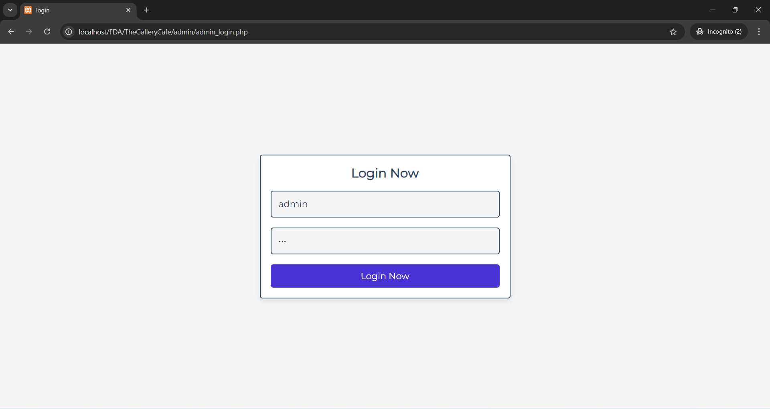

Figure 1: Admin Login

Figure 2: Login Successfully Screen

|  |  |  |  |  |
| --- | --- | --- | --- | --- |
| Test Case ID | Description | Precondition | Steps | Expected Result |
| TC02 | Verify admin login with incorrect credentials | Admin account exists | Enter incorrect credentials and attempt to log in | Admin should receive an error message indicating invalid credentials |

Figure 3: Incorrect Logins

|  |  |  |  |  |
| --- | --- | --- | --- | --- |
| Test Case ID | Description | Precondition | Steps | Expected Result |
| TC03 | Verify adding a product to the cart without logging in | User is not logged in | Select a product and attempt to add it to the cart | User should be prompted to log in or continue as a guest |

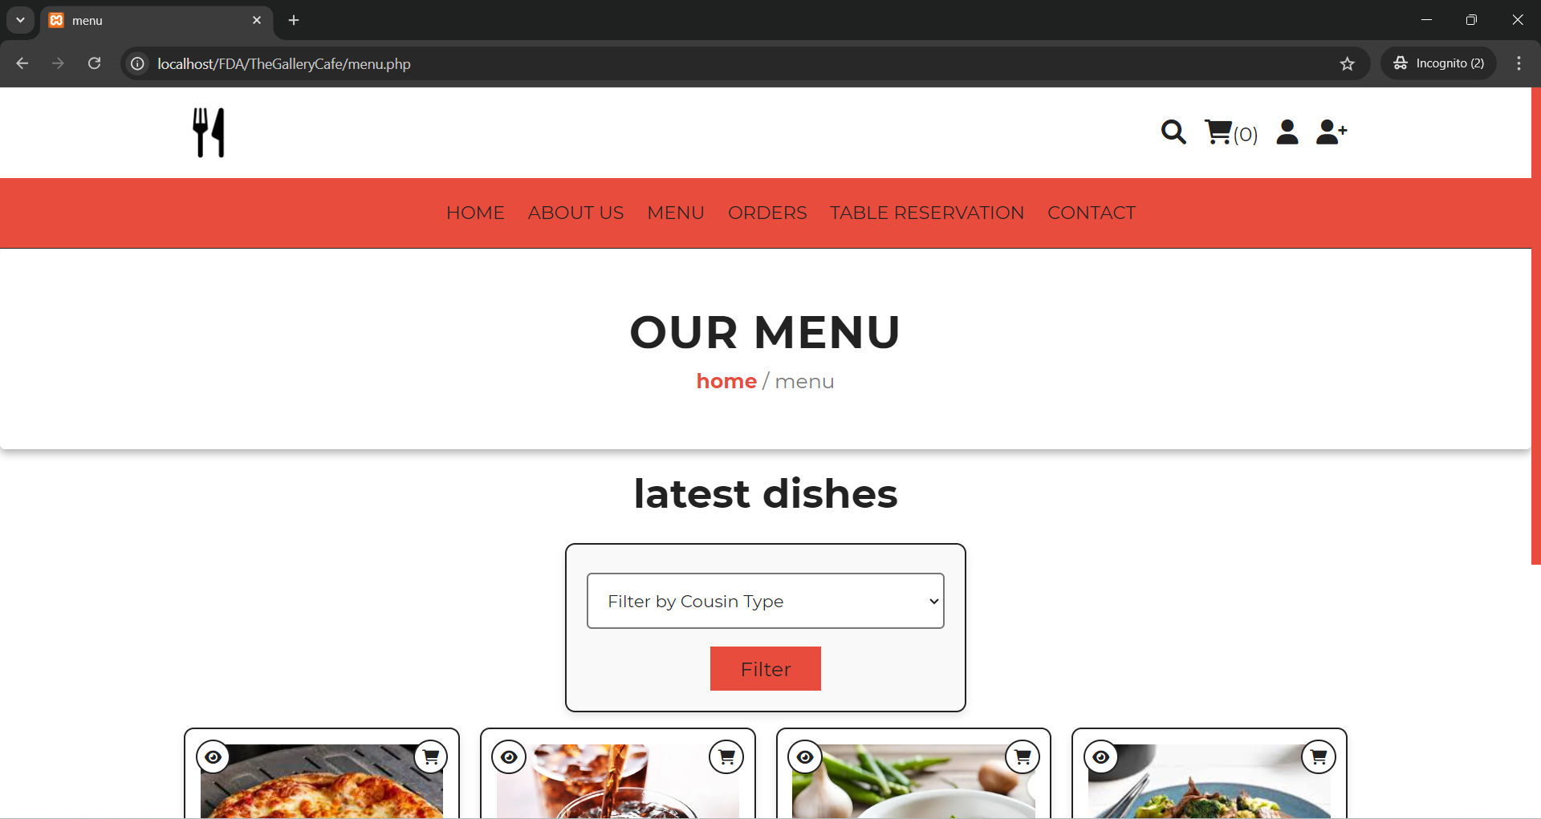

Figure 4: Without login the system

Figure 5 : Prompt to login when item add

|  |  |  |  |  |
| --- | --- | --- | --- | --- |
| Test Case ID | Description | Precondition | Steps | Expected Result |
| TC04 | Verify quantity validation in the cart | User is logged in | Update the quantity of a product to a negative number or zero | User should receive an error message indicating invalid quantity |

Figure 6 : Invalid count

|  |  |  |  |  |
| --- | --- | --- | --- | --- |
| Test Case ID | Description | Precondition | Steps | Expected Result |
| TC05 | Verify email validation in the contact form | User accesses the contact form | Enter an invalid email format and submit the form | User should receive an error message indicating an invalid email format |

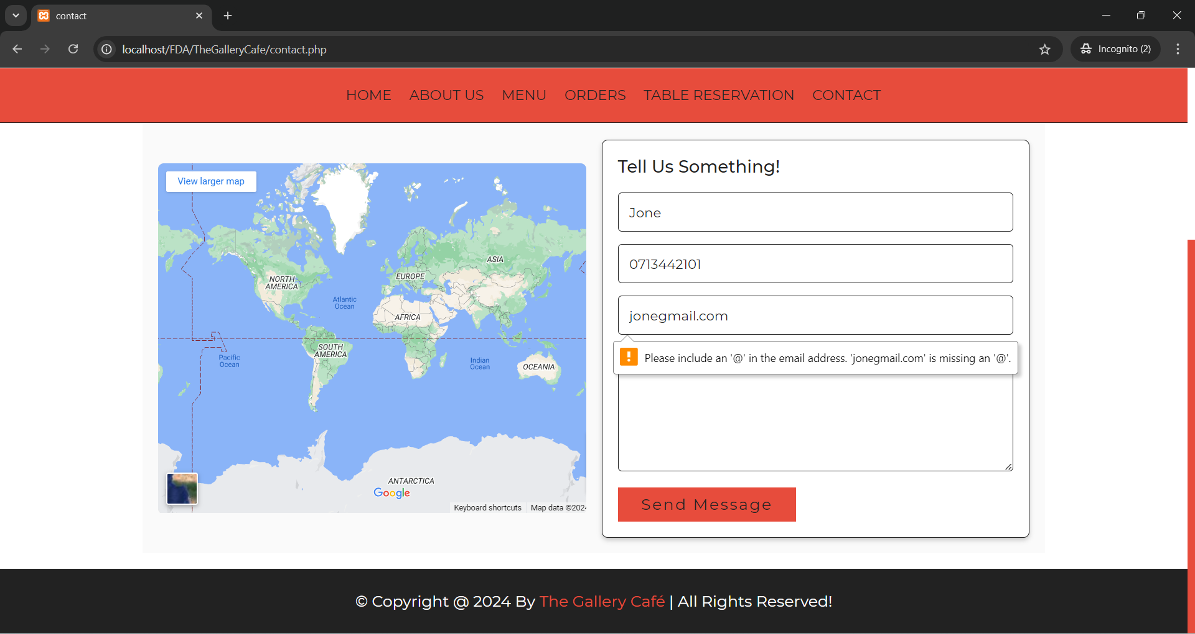

Figure 7: Email Validation

|  |  |  |  |  |
| --- | --- | --- | --- | --- |
| Test Case ID | Description | Precondition | Steps | Expected Result |
| TC06 | Verify required fields in the contact form | User accesses the contact form | Leave one or more required fields empty and submit the form | User should receive an error message indicating that all fields are required |

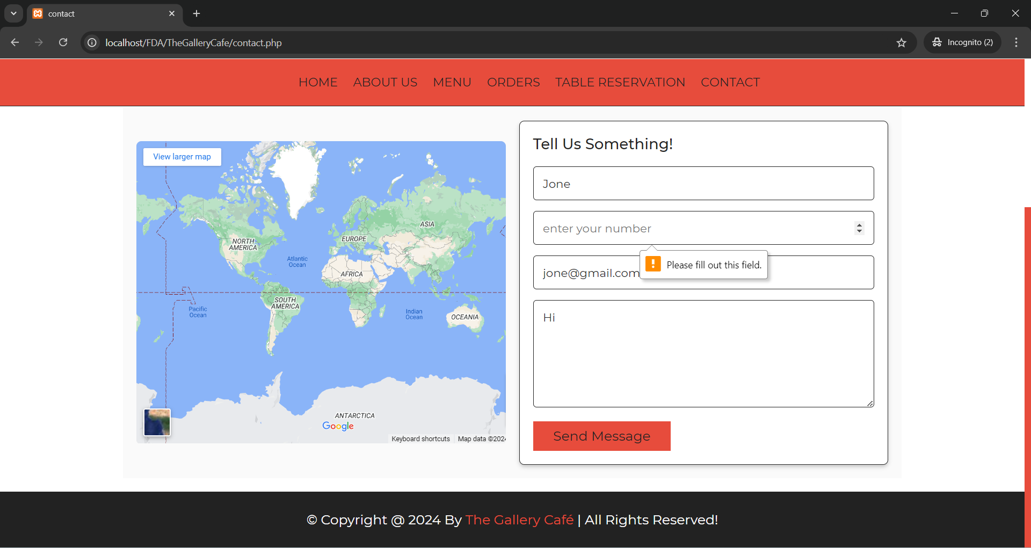

Figure 8 : Emplty feild validation

|  |  |  |  |  |
| --- | --- | --- | --- | --- |
| Test Case ID | Description | Precondition | Steps | Expected Result |
| TC07 | Verify address field validation in the order form | User has products in the cart | Enter an invalid or empty address and attempt to place an order | User should receive an error message indicating that a valid address is required |

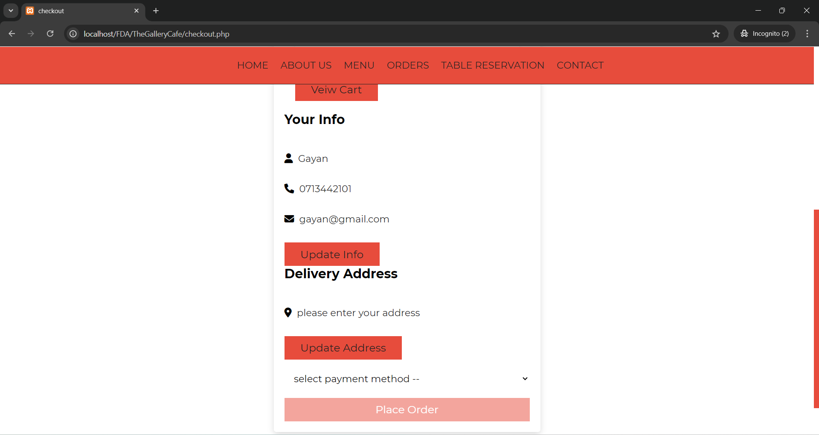

Figure 9 : Checkout UI

|  |  |  |  |  |
| --- | --- | --- | --- | --- |
| Test Case ID | Description | Precondition | Steps | Expected Result |
| TC08 | Verify method field validation in the order form | User has products in the cart | Leave the payment method field empty and attempt to place an order | User should receive an error message indicating that a payment method is required |

Figure 10 : Payment methos selection validation

|  |  |  |  |  |
| --- | --- | --- | --- | --- |
| Test Case ID | Description | Precondition | Steps | Expected Result |
| TC09 | Verify price field validation when adding a new product | Admin is logged in | Enter a negative price or leave the price field empty | Admin should receive an error message indicating an invalid price |

Figure 11: Empty Price Validation

|  |  |  |  |  |
| --- | --- | --- | --- | --- |
| Test Case ID | Description | Precondition | Steps | Expected Result |
| TC10 | Verify reservation time validation | User is logged in | Enter a reservation time in the past and submit the form | User should receive an error message indicating an invalid reservation time |

Figure 12 : No of people validation

|  |  |  |  |  |
| --- | --- | --- | --- | --- |
| Test Case ID | Description | Precondition | Steps | Expected Result |
| TC11 | Verify capacity field validation when adding a new table | Admin is logged in | Enter a negative number or zero for capacity | Admin should receive an error message indicating an invalid capacity |

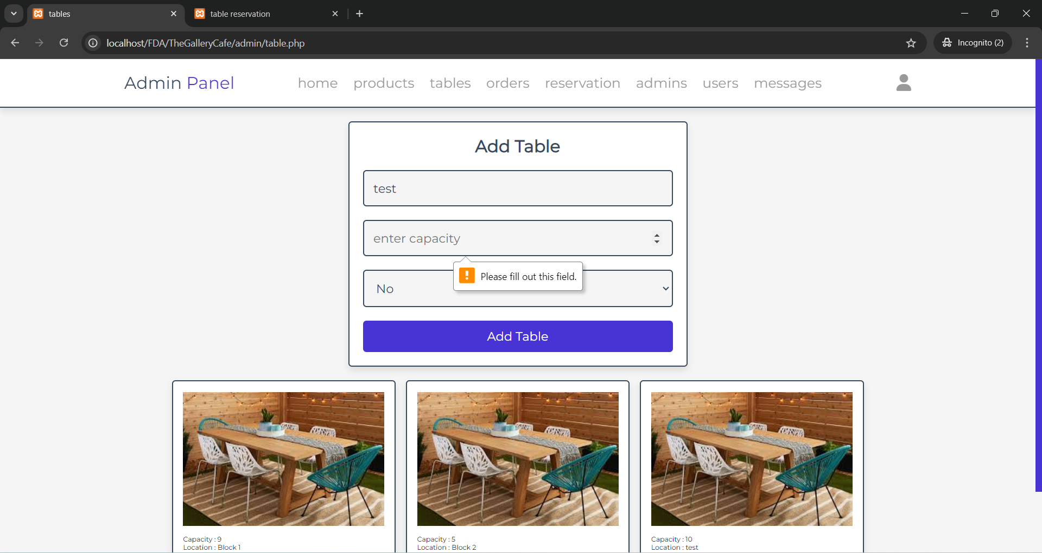

Figure 13 : Capcity feild validation

|  |  |  |  |  |
| --- | --- | --- | --- | --- |
| Test Case ID | Description | Precondition | Steps | Expected Result |
| TC12 | Verify user registration with an already registered email | User accesses the registration page | Enter an email that is already registered and submit the form | User should receive an error message indicating that the email is already registered |

Figure 14 : email validation

|  |  |  |  |  |
| --- | --- | --- | --- | --- |
| Test Case ID | Description | Precondition | Steps | Expected Result |
| TC13 | Verify phone number validation during user registration | User accesses the registration page | Enter an invalid phone number format and submit the form | User should receive an error message indicating an invalid phone number format |

Figure 15 : Phone number validation

|  |  |  |  |  |
| --- | --- | --- | --- | --- |
| Test Case ID | Description | Precondition | Steps | Expected Result |
| TC14 | Verify required fields during user registration | User accesses the registration page | Leave one or more required fields empty and submit the form | User should receive an error message indicating that all fields are required |

Figure 16 : required feild validation

|  |  |  |  |  |
| --- | --- | --- | --- | --- |
| Test Case ID | Description | Precondition | Steps | Expected Result |
| TC15 | Verify user login with correct credentials | User account exists | Enter valid credentials and attempt to log in | User should be successfully logged in |

Figure 17 : User registration

|  |  |  |  |  |
| --- | --- | --- | --- | --- |
| Test Case ID | Description | Precondition | Steps | Expected Result |
| TC16 | Verify user login with incorrect credentials | User account exists | Enter incorrect credentials and attempt to log in | User should receive an error message indicating invalid credentials |

Figure 18 : Incorrect login

|  |  |  |  |  |
| --- | --- | --- | --- | --- |
| Test Case ID | Description | Precondition | Steps | Expected Result |
| TC17 | Verify password field validation during user login | User account exists | Try to log in with an empty password field | User should receive an error message indicating that the password is required |

Figure 19 : Password feild validation

|  |  |  |  |  |
| --- | --- | --- | --- | --- |
| Test Case ID | Description | Precondition | Steps | Expected Result |
| TC18 | Verify order history is displayed correctly | User has placed orders | Access the order history page | Order history should display all past orders correctly |

Figure 20 : Order History

|  |  |  |  |  |
| --- | --- | --- | --- | --- |
| Test Case ID | Description | Precondition | Steps | Expected Result |
| TC19 | Verify cart is emptied after successful order placement | User has products in the cart | Place an order | Cart should be emptied after the order is placed successfully |

Figure 21 : Existing item in cart

Figure 22 : After checkout the cart

|  |  |  |  |  |
| --- | --- | --- | --- | --- |
| Test Case ID | Description | Precondition | Steps | Expected Result |
| TC20 | Verify special requests field in reservations | User is logged in | Enter a special request and submit a reservation | Special request should be saved and displayed in the reservation details |

Figure 23 : Special request

# References

*Pizza Hut Sri Lanka*. (n.d.). https://www.pizzahut.lk/

*Sri Lankan Restaurant in Colombo | Culture Colombo*. (2023, July 25). Culture Colombo. https://culturecolombo.lk/

*Elevating Seafood Dining in Sri Lanka | Ministry of Crab*. (n.d.). Elevating Seafood Dining in Sri Lanka | Ministry of Crab. https://www.ministryofcrab.com/colombo/